**SHEET -4 – VI EDITOR, USER ACC MGMT AND FILE OWNERSHIP**

2. User Account management (Become root user) – Create users and groups complete exercise 3 and then perform delete.

a. Add users – Saurav,Robin,Ronaldo and Messi using useradd cmd

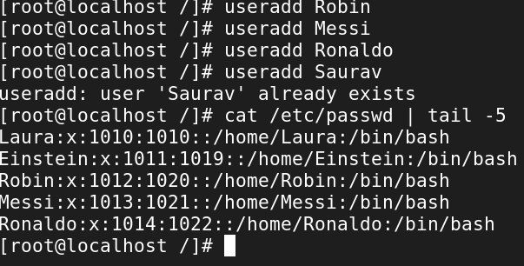

b. Add groups – Football and Cricket using groupadd cmd

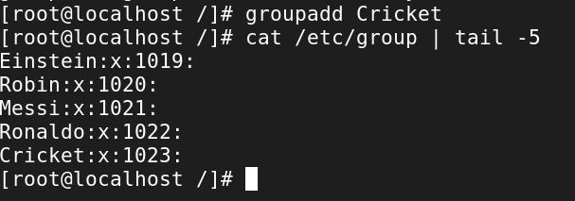

c. Add Saurav and Robin to Cricket grp using usermod -aG groupname username

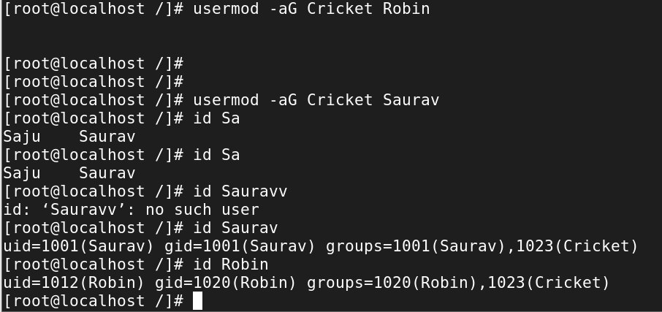

d. Add Messi and Ronaldo to Football grp using usermod -aG groupname username

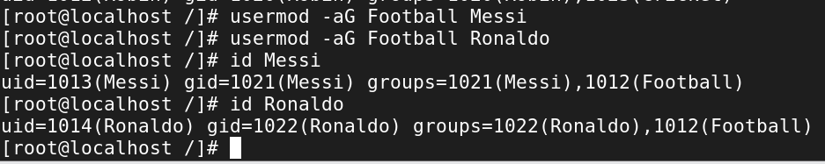

e. Verify using id cmd – id username

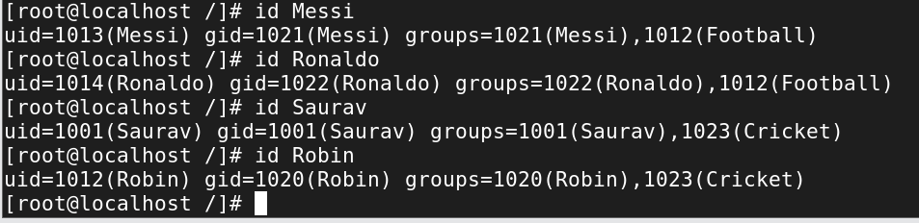

f. Verify using groups cmd – groups username

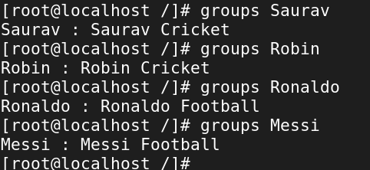

g. Add user Dravid to group Cricket – useradd -G groupname username

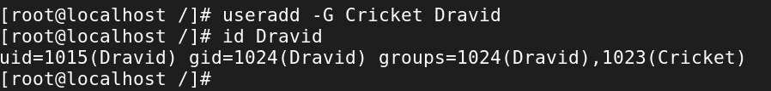

h. Add user Neymar to group Football – useradd -G groupname username

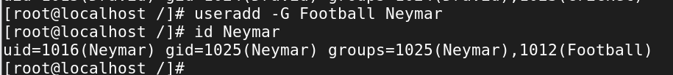

1. Observe the files - /etc/passwd , /etc/shadow , /etc/groups

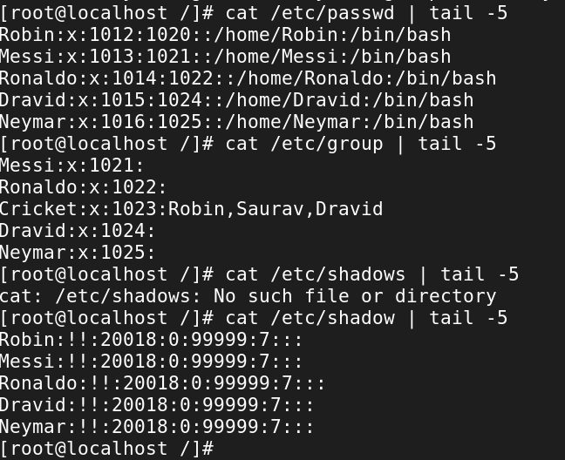

j. Create a group players. Add all the users to Players grp

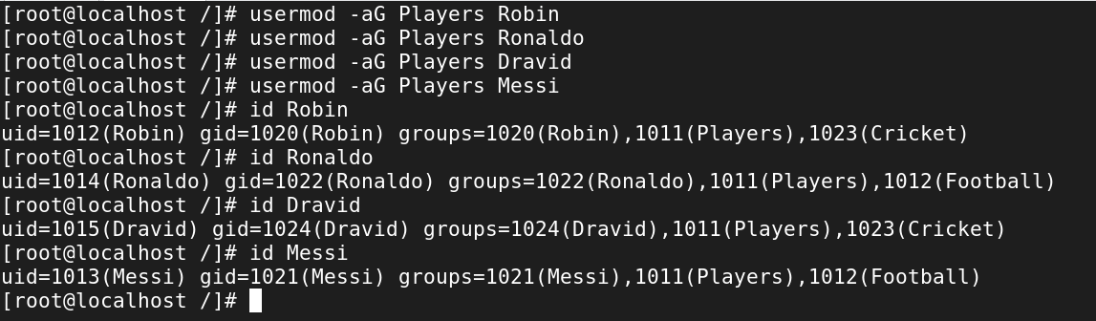

k. Delete user Saurav and Messi including their home directory



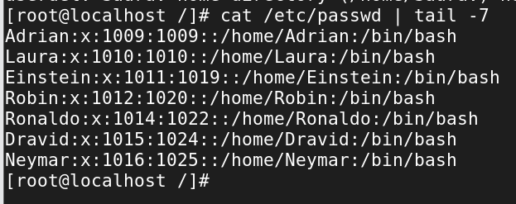

l. Remove user Neymar and Dravid from Player grp using gpasswd -d username groupname

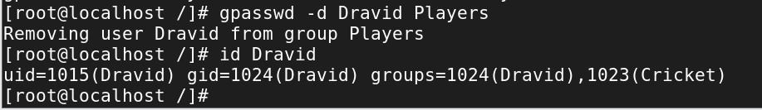

m. Delete group Football using groupdel cmd

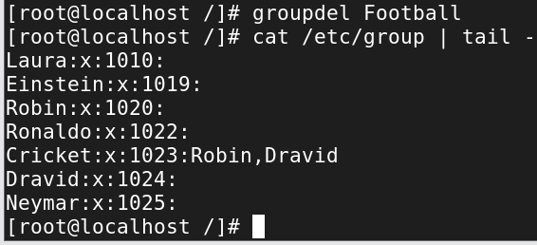

n. Create group Chess and add users Pragg,Anand,vaishala and gukesh

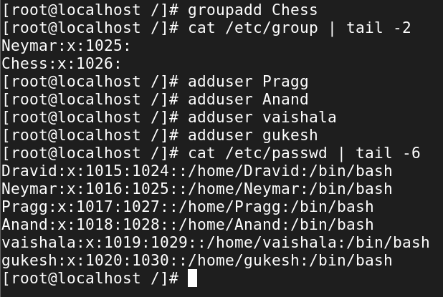

o. Delete user Pragg and Anand using userdel -r username and observe the changes.

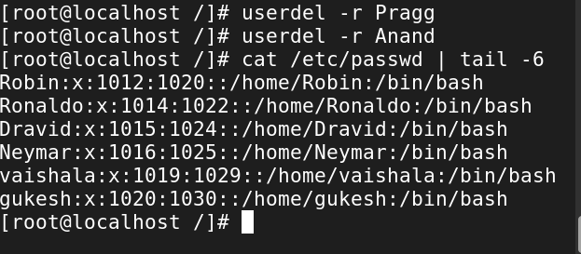

p. Add a user of your choice and add to any grp as primary group

i. Usermod -g groupname username

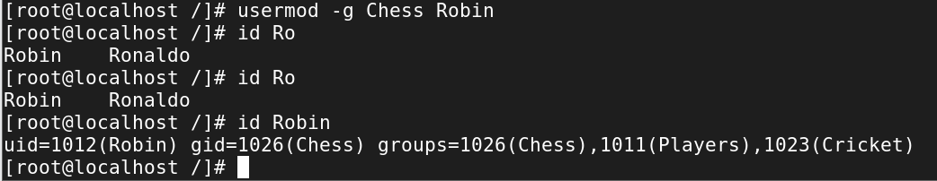

ii. Delete this group and observe the changes.

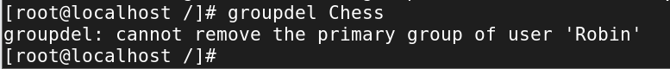

3. File Ownership commands

a. Cricketers file under your home directory change owner to Saurav using chown username filename

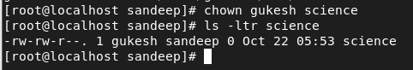

b. Sample file under your home directory change group to Cricket using chgrp grpname filename

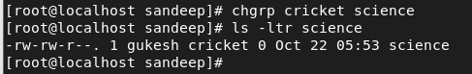

c. Change owner and grp of file People using chown username:groupname filename

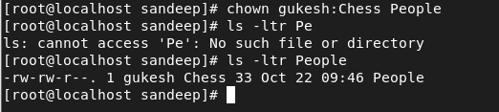

d. For the CEO directory change owner to Neymar and grp to cricket

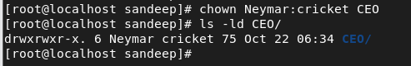

e. Observe the changes in its sub directories and files

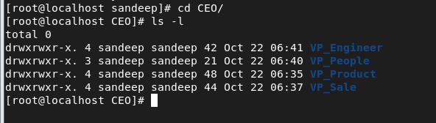

f. For the CEO directory change owner to Neymar and grp to cricket using -R option



g. Observe the changes in its sub directories and files

